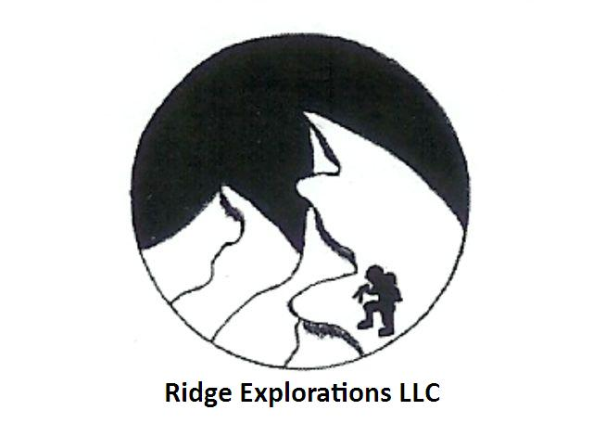
Letter to Parents of Adolescent Students
Hi Parents

Congratulations for helping your child take the first step towards learning backcountry safety.

I think it is great that the kids are getting some education. I would like to make sure the parents understand what we are dealing with....such as what the kids plan to do in the snowy mountains and what the limitations are.

We are all limited in the knowledge we can have about the avalanche phenomenon. We learn how to make safe decisions in spite of the limitations by setting rules for ourselves and accepting our limitations. Taking a basic avalanche class is no guarantee of safety in and of itself. Your child will not be ready to head into the mountains where there are avalanches. You cannot rest assured that by sending your child to avalanche class, that the danger is passed. My class gives some tools and skills to begin a sensible path towards more knowledge and safe behavior. One of the things I want people to learn from my classes is that there is need of more training.

These are things which I teach but since we are dealing with youngsters and sophisticated concepts, I want the parents to have a realistic understanding what the kids have learned and what they have not learned. This is probably he biggest reason I want parents along. I can keep them safe when they are with me, but what about after they are on their own?

I have made it through over thirty years of wintery mountain adventure by accepting certain personal limitations and setting rules for my behavior in the backcountry. I am eager to pass this on to your child.

Don Langlois, Ridge Explorations Director

www.ridgeexplorations.com
Phone: 253-891-0149 Email: info@RidgeExplorations.com

